AF 09-07
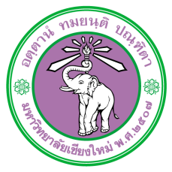
Research Project Duration Clarification Form

Address (Please specify)

Date Click or tap to enter a date.

Subject Research Project Duration Clarification

To Chairperson of Chiang Mai University Research Ethic Committee

As I (please specify research project leader) Bachelor’s Degree Student / Master’s Degree Student / PhD Candidate / Lecturer / Researcher Program / Department Click or tap here to enter text. Faculty Click or tap here to enter text. submitted research proposal to Chiang Mai University Research Ethic Committee for the research entitled Click or tap here to enter text.
I would like to clarify that as I informed the data collection period in the research project between Click or tap to enter a date. and Click or tap to enter a date. But since the research proposal has not been approved by the Chiang Mai University Research Ethic Committee, the data collection, hence, cannot be processed. Please notify that the new data collection period will be between Click or tap to enter a date. and Click or tap to enter a date.

Please be informed accordingly.

(Signature).....................................................................
(Name of Research Project Leader)
Research Project Leader

(Signature).....................................................................
(Name of Thesis Advisor)
Thesis Advisor

