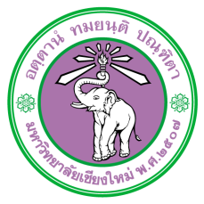

Fee Payment Notification Form
Subject Fee Payment Notification
To Chairperson of Chiang Mai University Research Ethic Committee

I Click or tap here to enter text.
Status Click or tap here to enter text. Affiliation Click or tap here to enter text.
Research Project Code Click or tap here to enter text.
Research Project Title Click or tap here to enter text.
notifying the payment of fees to Chiang Mai University Research Ethic Committee as follows.
☐ Submission fee of research proposal 10,000.- baht (ten thousand baht only).
☐ Certificate renewal fee of the research project funded by any unit within Chiang Mai University 500.- baht (five hundred baht only).
☐ Certificate renewal fee of the research project funded by any unit outside Chiang Mai University 1,000.- baht (one thousand baht only)
☐ The fee for the certifying documents that have been approved from Chiang Mai University Research Ethic Committee including search fee 50.- baht per time / project and the certifying fee 10.- baht per page. For the total of Click or tap here to enter text. baht

I have already transferred the above fees into the account of the Office of Chiang Mai University Research Ethic Committee as follows.
Account Name : Chiang Mai University Research Ethic Committee
Bank Name : Siam Commercial Bank Branch : Chiang Mai University
Bank Account Number : 667 - 407019 – 0 Type of Account : Saving

Attached herewith is the copy of the money transfer document as an evidence to confirm the fee payment at the above amount. In this matter, please issue a receipt as follows
Name : Click or tap here to enter text.
Address : Click or tap here to enter text.

Signature...................................................
(Click or tap here to enter text.)
Date Click or tap to enter a date.

